***Game Directions and Templates***

Struggling readers need repeated practice decoding and reading specific letter-sound correspondences in words. Most students will find it more enjoyable to practice reading words when a game format is provided.

Games also provide an opportunity for differentiated instruction. Students who need practice reading words with different letter-sound correspondences may still play the same game, with each student having his own specific deck of word cards to be read as part of the game. Use the Word Lists in each section of this Guide to create card decks for your students.

Directions are provided for each game, followed by templates for the game boards and word cards.

Word Block

• Use the provided grid and template word cards or create a grid of equal size squares on a poster board and two sets of square cards with a word written on one or both sides. The cards should fit into the squares on

the grid. Each set of cards should either be a different color or the words should be a different color to differentiate between players.

• Have students take turns drawing a card from their pile and then reading the word on the card. If the student correctly reads the card, he/she may place it in any square on the grid.

• The object of the game is to try to get five cards in a straight line (horizontally or vertically) before the other player. Students can use their cards to block an opponent from getting five in a row, as well as try to get five of their own cards in a row.

Moon Shot

*Also need: Tokens or playing pieces for each player*

• Use the provided game board or create a similar playing board on a poster board.

• Then create three sets of cards using the templates:

• Word Cards

• Good to Go Cards

• Problem Cards

• You will also need to provide some kind of small marker or token as playing pieces for each student.

• Have students take turns drawing word cards. If a student reads the word card correctly, then he/she can draw a Good to Go card and follow the directions on the card. If a student does not read the word correctly, then he/she will draw a card from the Problem pile and follow the directions

on that card.

• The first student to make it to the “moon” is the winner.

Roll, Flip, Read

• Create a set of cards for each player (see template) that has a word to be read on one side and a number on the other side.

• Call out a number at random and have each student take turns finding

a card with that number on it in his or her stack. The student then reads

the card aloud. If the word is read correctly, the student may then roll a

die and whatever number it lands on is the number of points he or she

receives.

• The student with the most points is the winner.

• An alternate way to play that does not involve dice is for each card to have a pre-assigned point value based on the difficulty of the word.

Race against the Clock

• Create a set of word cards for each player (see template). Assign each word a point value based on the difficulty of the word; you may want to assign one point for one-syllable words, two points for two-syllable words, three points for three-syllable words, and so on.

• Each player gets a preset time limit to attempt to read as many words

as possible within the time. Students get points for the words they read

correctly and get no points for words they get wrong or skip.

• The student with the most points is the winner.

Crazy Eights Variation

• Create a deck of word cards. Each word should be one of four colors

(suits) and there should be an equal number of each color.

• Give each player five cards to start. Put the rest of the deck in the middle and f lip the top card over next to the deck. This face-up card becomes the discard pile.

• Taking turns, each student can either play a card that is the same color or that starts with the same letter as the card at the top of the discard pile. To be able to play a card, a student must correctly read the card or they lose their turn.

• If a student does not have a card that is either the same color or that starts with the same letter as the top card of the discard pile, then he or she can draw from the deck. If there are no more cards left in the deck, shuff le the discard pile and that becomes the new deck.

• The first student to run out of cards is the winner.

• You may also wish to include *skip*, *add*, *draw 1*, *draw 2*, *draw 3*, and

*reverse cards*.

Journey through Space

• Using the card templates, create a set of cards as follows. Write one word on each card. Some cards will only have words; others may have words with an alien symbol or comet symbol. (See card templates.)

• Place all of the cards in a container. Pass the container around, having each student draw a card and read the word aloud. If he or she reads the word correctly, then he/she gets to keep the card. If he/she does not read the word correctly, he/she places the card back into the can. If a student correctly reads a word on a card with an alien symbol, he/she can take

a card from another player. If a student correctly reads a word on a card with a comet symbol, he/she gets a second turn.

• The student with the most cards at the end of the game wins.

Flip

• To play, either call out a number or have the student roll a die (one or two) and then read the word that corresponds to the number rolled. If the student reads the word correctly, then have him or her “f lip” the word (fold the row over).

• The first student to f lip all of the words is the winner.

Checkers

• Use the provided checkerboard and checkers template or a store bought checkerboard with a set of checkers.

• Create a set of words cards for each student.

• The rules are the same as regular checkers except that in order to make a move, the student must first draw and read a word card correctly. If the student reads the card correctly, then he/she may make a move. If he/she misreads the word, the turn is lost.

• The first player to take all of the other player’s pieces is the winner.

Race to the Top

• Make a set of words cards for each player.

• Each student gets his/her own ladder and a set of word cards. Students

f lip over a card and if they read the word correctly, they can move their

marker up a space; if they misread a word, they fall down a rung. First

one who gets to the top wins.

Over the Rainbow

• Create a set of clue envelopes for each player. Each envelope should contain a card with either a word or instructions on it. Make as many envelopes as there are spaces from the start place to the pot of gold.

• To play, have each student take turns opening his/her first clue. The student opens the first clue and does what the clue says (e.g. read these words); if he/she completes the task correctly, then he/she can move on

the board to the next space, where he/she will receive their next clue. The first one to the pot of gold wins.

Swim to the Finish

• Make a copy of the template game board.

• Each student should write his/her name at the top of a column or “swim lane.”

• Pick out a word for a student to read aloud.

• If the student reads the word correctly, then he/she may place a check mark in one of the squares of his or her “swimming lane.” If a student does not read the word correctly, he/she may not check a square.

• Each student gets only one chance to read a word during his/her turn.

Regardless of whether the student reads his/her word correctly, play then

moves to the next student.

• The first person to reach the end of the pool wins.

Baseball Game

• Write target words on cards. You may wish to also assign value to the card based on the difficulty of the word. Examples include: base hit, double, triple, homerun, etc.

• Use the game board on the template with playing pieces or draw a baseball diamond similar to the template on the board.

• Divide the group into two teams, having one team come to the front of the room and line up in front of the board

• Each team takes a “turn at bat” as follows:

• Pick a card from the pile and ask the first person on the team to read it. If the word is read correctly, draw a line from home plate to first base, signifying a “hit.” This player should go to the back of the team’s line, while the next player comes forward to read the

next card. If he/she reads the word correctly, draw a line from first

to second base. Play continues in this way so that each time a player

reads a word correctly, a line is drawn to the next base. If the fourth

player reads the word correctly, draw a line from third base to home

plate and mark “1 run” for this team. Play continues by the members

of this team so long as no words are misread. When a word is

misread, the next team takes its turn at bat.

• As in the actual game of baseball, any “players left on base” when a word is misread, do not count or add to the score.

**Word**

**Block**

**Player One**

**Cards**

**Player Two**

**Cards**

place cards here

place cards here

|  |  |  |  |  |
| --- | --- | --- | --- | --- |
|  |  |  |  |  |
|  |  |  |  |  |
|  |  |  |  |  |
|  |  |  |  |  |
|  |  |  |  |  |

**Word Block Template Cards**

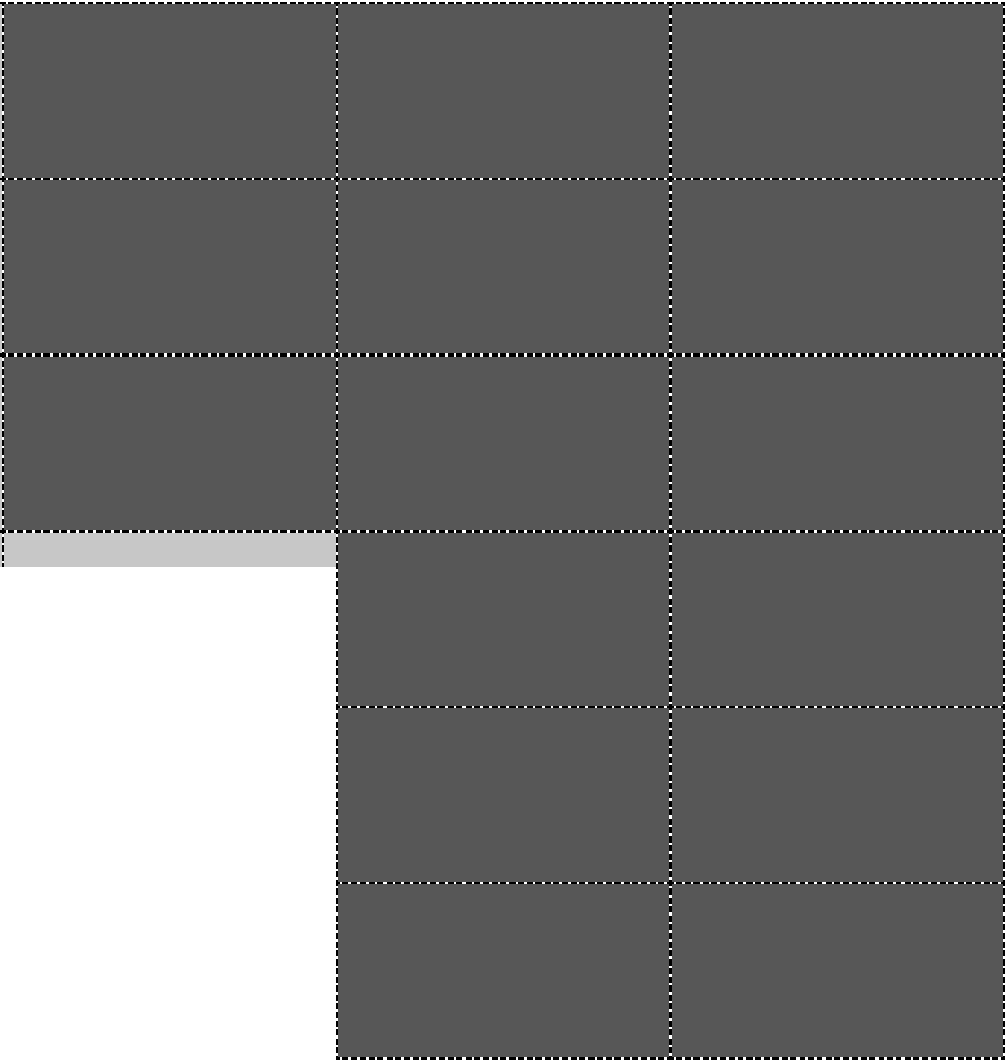m ·-------------------------------------·-------------------------------------·-------------------------------------

!3[ --------------------------------------·-------------------------------------·-------------------------------------

©

*i5* Q

o*w* :m:0

3

*5* <D

*g*1--:-:J---·--------------------------------------------------------------------------------------------------------

6-

*Directions: Copy template and then write different words on each card, according to the letter-sound correspondences students need*

..... *to practice. Then cut cards apart.*

0

U'l

**Moon Shot**



**STAR**

*Grade 2 | Assessment and Remediation Guide* **107**

© 2013 Core Knowledge Foundation

**Template for Moon Shot Word Cards**

*Directions: Copy the template several times and then write different words on the cards for different students. Cut out the cards.*

-----------------------------------------------------·-----------------------------------------------------

*Grade 2* I *Assessment and Remediation Guide* **109**

© 2013<X>re KnowO>d;Je Fourlda!bn

**Moon Shot Good To Go Cards**

*Directions: Copy the template and cut out the cards.*



Move Forward



Two Spaces!



Move Forward

One Space!



Move Forward



Three Spaces!



Move Forward

Four Spaces!



Move Forward



One Space!



Move Forward

Two Spaces!



Move Forward



Two Spaces!



Move Forward

Five Spaces!



Move Forward



One Space!



Move Forward

Two Spaces!



**Moon Shot Problem Cards**

*Directions: Copy the template and cut out the cards.*

Sorry! Lose A Turn Go back one space



Go back two spaces Go back one space



Go back one space Go back three spaces



Go back three spaces Go back two spaces



Go back four spaces Sorry! Lose A Turn



**Word Card Template for Roll, Flip, Read**

*Directions: Copy one template for each student. Cut out cards and write words on the back of each card.*

|  |  |  |  |  |
| --- | --- | --- | --- | --- |
|  | 1 |  | 2 |  |
| 3 |  | 4 |  |
| 5 |  | 6 |  |
| 7 |  | 8 |  |
| 9 |  | 10 |  |
|  |  |  | *Grade 2 | Assessment and Remediation Guide* | **115** |

**Race against the Clock**

*Directions: Copy template several times and write words on each card. Also write a point value based on the difficulty of the word. Cut out the cards.*

-----------------------------------------------------·-----------------------------------------------------

-----------------------------------------------------·-----------------------------------------------------

-----------------------------------------------------·-----------------------------------------------------

-----------------------------------------------------·-----------------------------------------------------

**Crazy Eights Variation**

*Directions: Copy template several times on four different colors of paper. Write words on each card;*

*cut out the cards.*

-----------------------------------------------------·-----------------------------------------------------

-----------------------------------------------------·-----------------------------------------------------

-----------------------------------------------------·-----------------------------------------------------

-----------------------------------------------------·-----------------------------------------------------

**Journey through Space**

*Directions: Copy the template several times and write words on each card. Cut out the cards*

-----------------------------------------------------·-----------------------------------------------------

-----------------------------------------------------·-----------------------------------------------------

-----------------------------------------------------·-----------------------------------------------------

-----------------------------------------------------·-----------------------------------------------------

*Grade 2* I *Assessment and Remediation Guide* **121**

**Journey through Space (Steal a Card)**

*Directions: Copy the template several times and write words on each card. Cut out the cards.*

Steal a Card Steal a Card

Steal a Card  Steal a Card  Steal a Card  Steal a Card  Steal a Card  Steal a Card 

Steal a Card  Steal a Card 

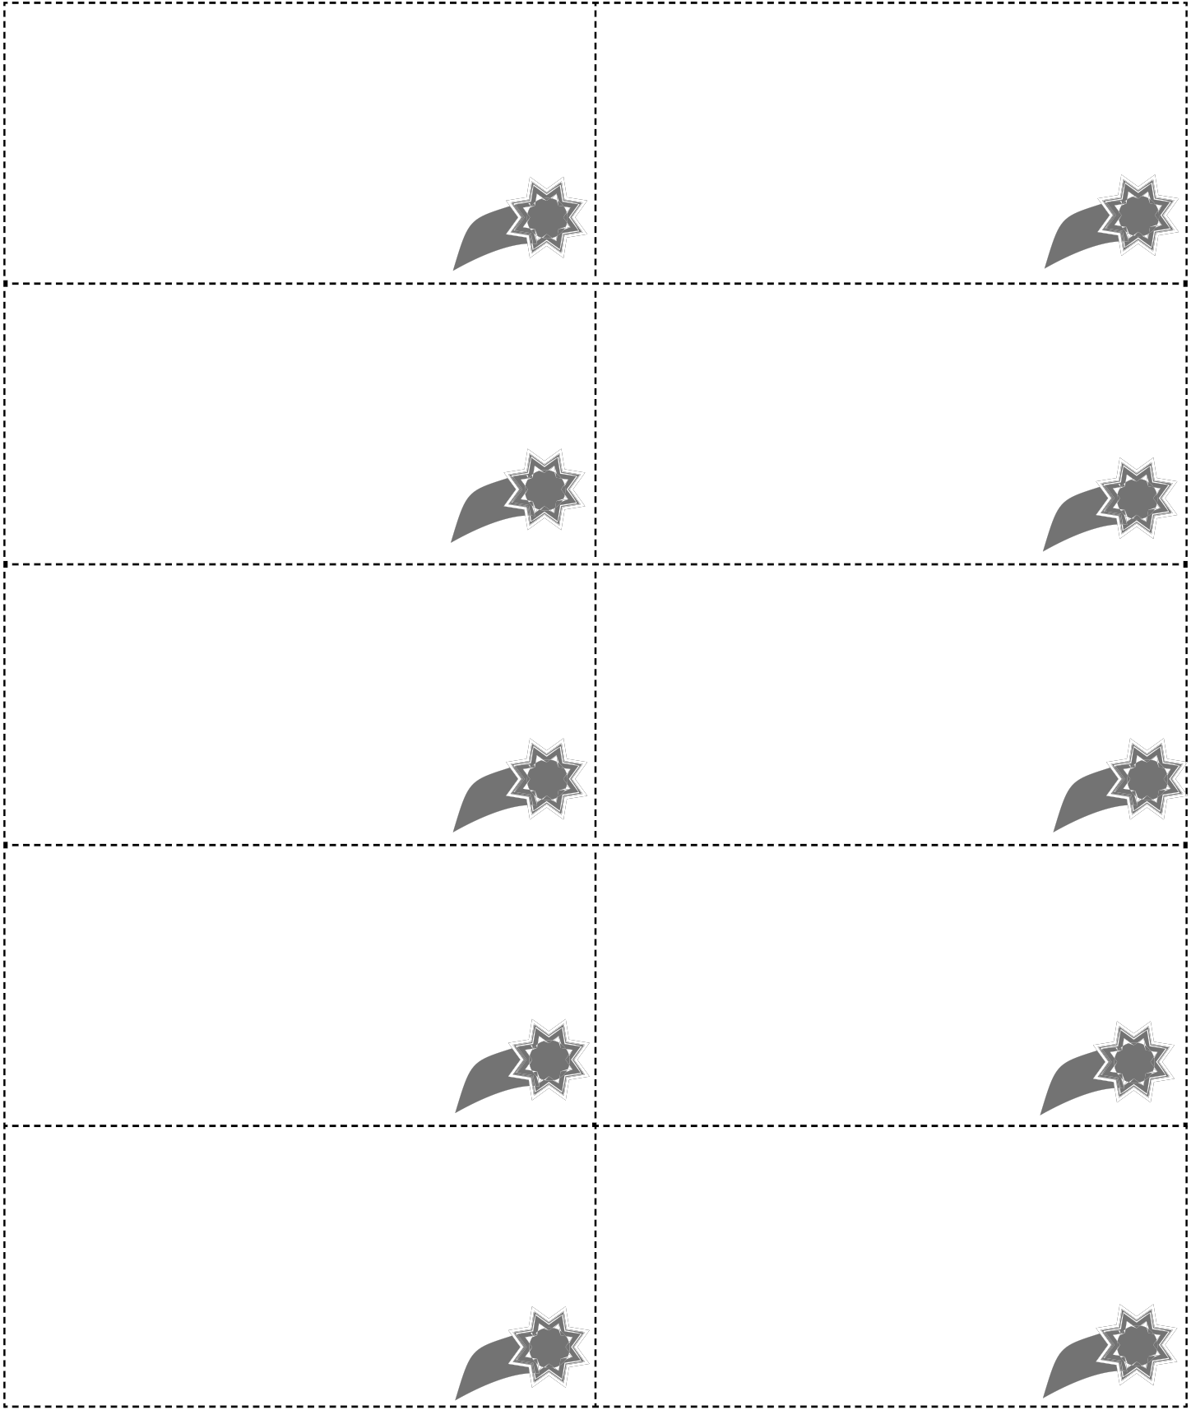**Journey through Space (Second Turn)**

*Directions: Copy the template several times and write words on each card. Cut out the cards.*

Take Another Turn Take Another Turn

Take Another Turn Take Another Turn Take Another Turn Take Another Turn Take Another Turn Take Another Turn Take Another Turn Take Another Turn

**Flip**

*Directions: Copy a template for each student and then write words on the back of each card. Cut out the cards.*

|  |  |  |  |
| --- | --- | --- | --- |
|  | 1 |  | 2 |
| 3 |  | 4 |
| 5 |  | 6 |
| 7 |  | 8 |
|  | 9 |  | 10 |

**Checkers**

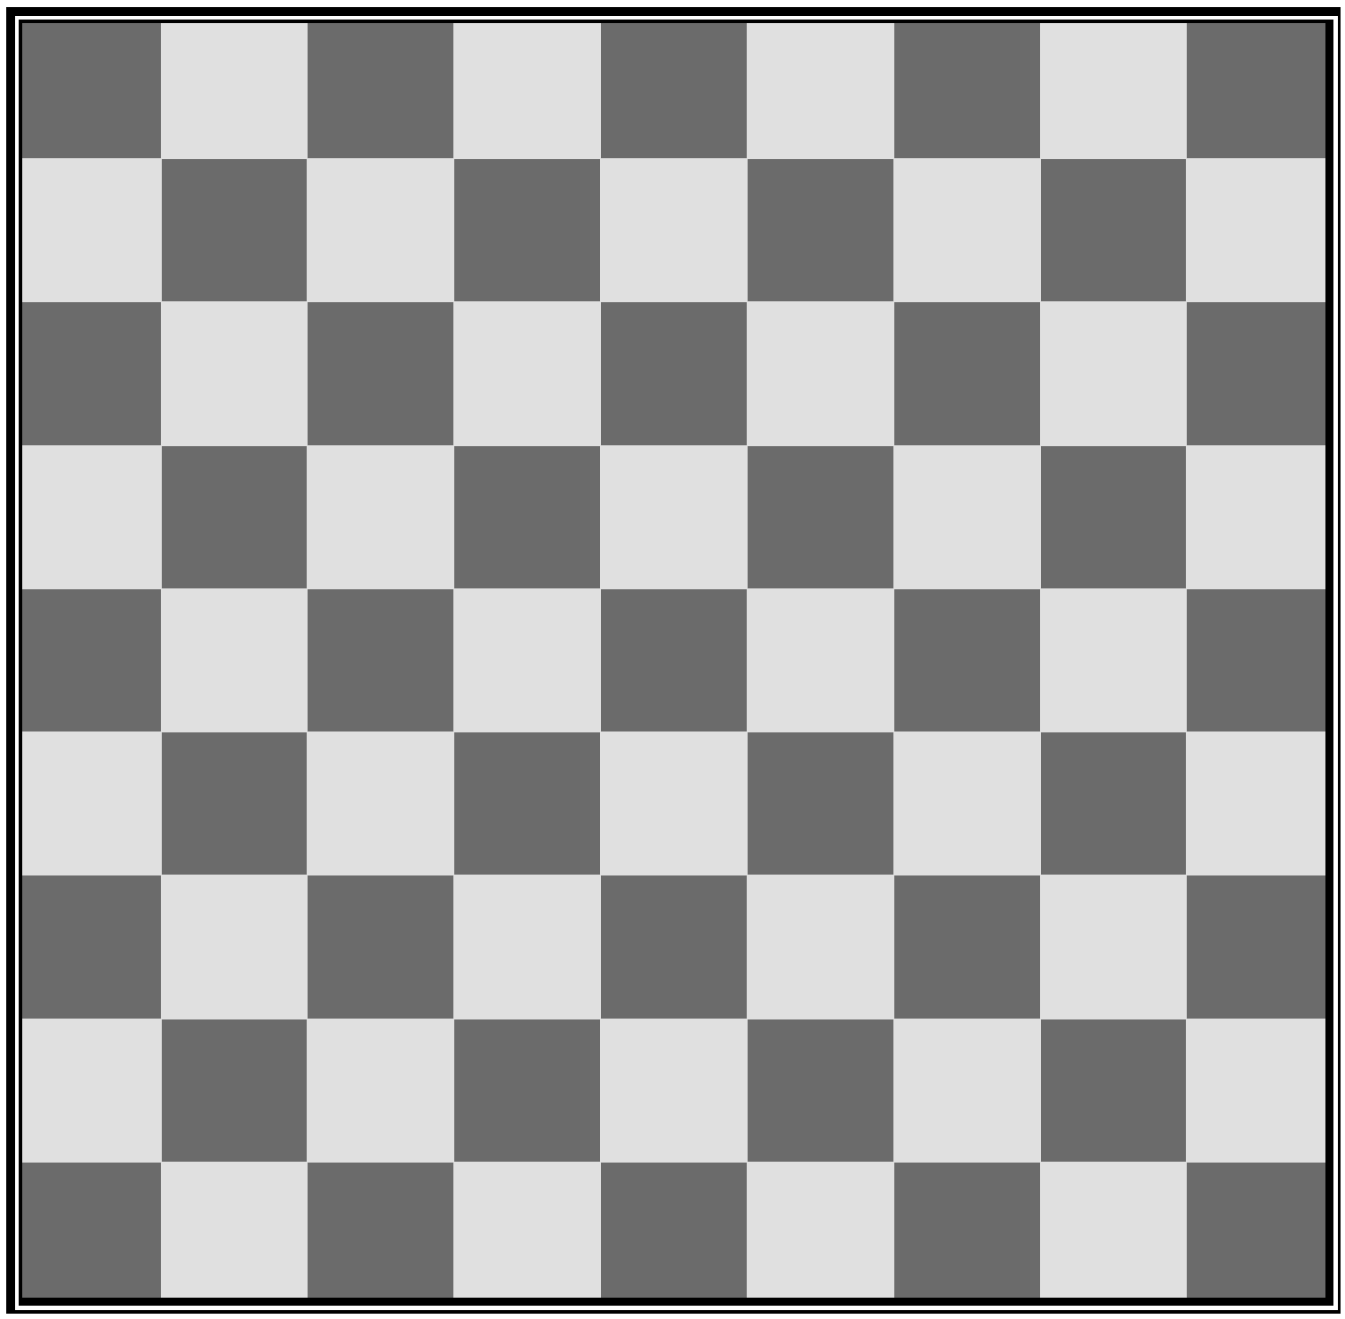

*Grade 2* I*Assessment and Remediation Guide* **129**

Checkers Pieces







*I*0\

0 *I*0

•\ *I*0

I *I*•0I

I I I I I I I I I I

t *I* I *I* t *I* ' i ' i

*1* .. t

--- --- --- --- ---

0• 0"

0 0" 0•

*I* \ *I* I *I* I *I* I I I I I I I I I I I I *I* I I I *I* I I \ I

.. ---

*1* t *1 1*

_ ...... --- ...... _..... ---

0,.

......

0 0,.

0 0,.

*I* •I I I *I*' .I *I* I *I*• I

I I I I I I I I I I

I *I* I I \ *I* I *I* I *I*

•

'

--- '

....

...

' ' .............. '

................

---



*Grade* 21 *Assessment and Remediation Guide* 131

**Checkers Word Cards**

*Directions: Copy template several times and write words on each card. Cut out the words.*

-----------------------------------------------------·-----------------------------------------------------

-----------------------------------------------------·-----------------------------------------------------

-----------------------------------------------------·-----------------------------------------------------

-----------------------------------------------------·-----------------------------------------------------

*Grade 2* I *Assessment and Remediation Guide*

© 2013 Core Knowledge Foundation

133

**r--**

....._

**Race to the Top** -

I I

*)* **l**

.. .

I I

*)* **l**

I I

I

.. .

I I

*)* **l**

I I

*)* **l**

.. .

I I

**l** -

**Player 1**

*Grade* 21 *Assessment and Remediation Guide* **135**

**r--**

....._

**Race to the Top** -

I I

*)* **l**

.. .

I I

*)* **l**

I I

I

.. .

I I

*)* **l**

I I

*)* **l**

.. .

I I

**l** -

**Player 2**

*Grade 2* I*Assessment and Remediation Guide* **137**

**Race to the Top Word Cards**

*Directions: Copy template several times and write words on each card. Cut out the words.*

-----------------------------------------------------·-----------------------------------------------------

-----------------------------------------------------·-----------------------------------------------------

-----------------------------------------------------·-----------------------------------------------------

-----------------------------------------------------·-----------------------------------------------------

*Grade 2* I *Assessment and Remediation Guide*

139

START

**Over the Rainbow**

1 2

3

4

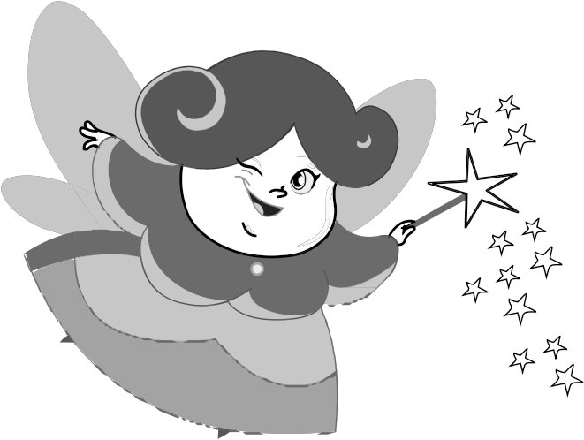

5

8 7 6

9

10 11

*Grade 2 | Assessment and Remediation Guide* **141**

**Over the Rainbow Word Cards**

*Directions: Copy template several times and write words or clues on each card. Cut out the words.*

-----------------------------------------------------·-----------------------------------------------------

-----------------------------------------------------·-----------------------------------------------------

-----------------------------------------------------·-----------------------------------------------------

-----------------------------------------------------·-----------------------------------------------------

*Grade 2* I *Assessment and Remediation Guide*

**143**

**Swim to the Finish**

|  |  |  |  |  |  |  |
| --- | --- | --- | --- | --- | --- | --- |
| **S** |  | **T** | **A** | **R** |  | **T** |
| .--------------1 | I |  | I I |  | I | 1.-------------- |

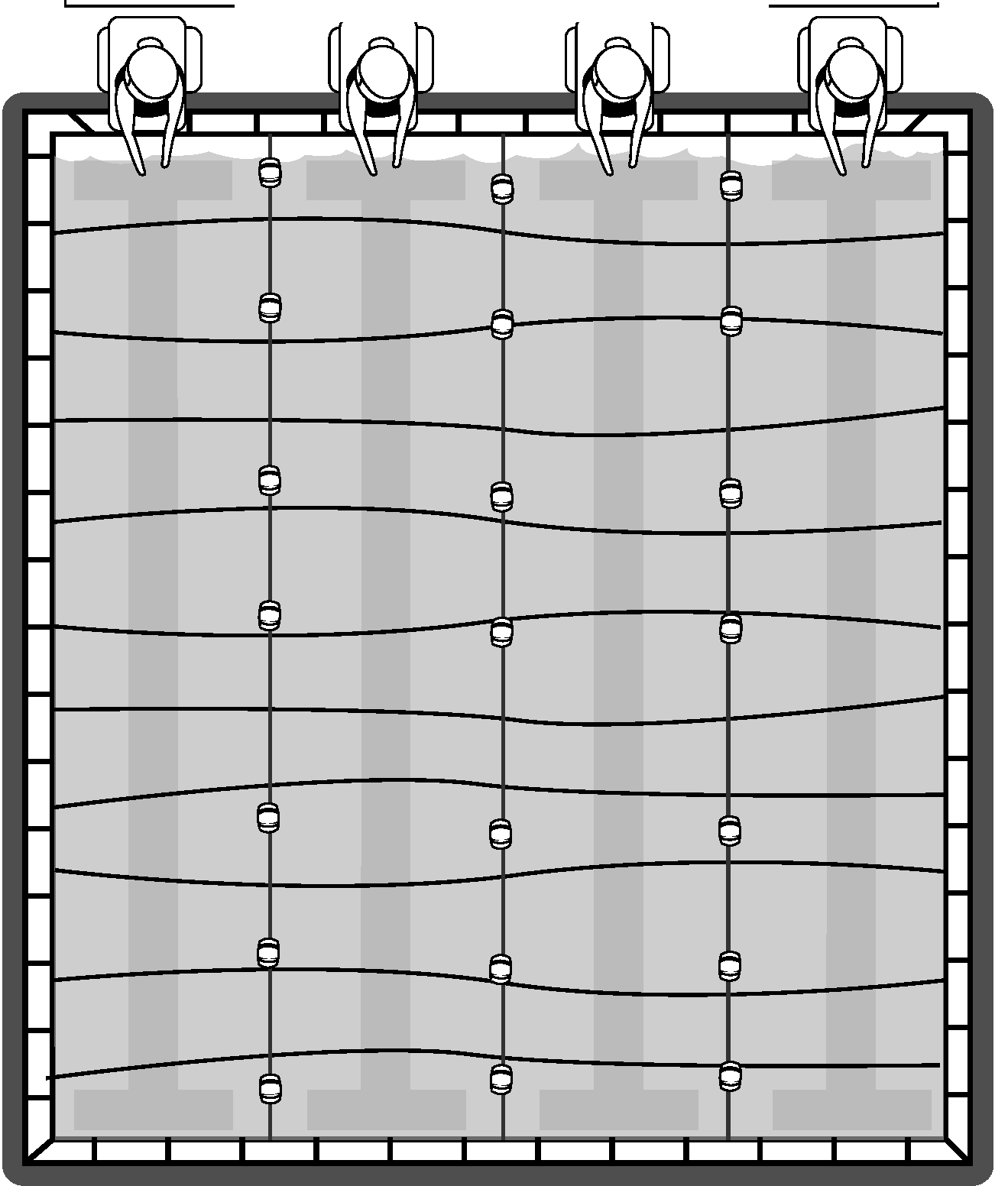

**F I N I S H**

**Swim to the Finish Word Cards**

*Directions: Copy template several times and write words on each card. Cut out the words.*

-----------------------------------------------------·-----------------------------------------------------

-----------------------------------------------------·-----------------------------------------------------

-----------------------------------------------------·-----------------------------------------------------

-----------------------------------------------------·-----------------------------------------------------

*Grade* 21 *Assessment and Remediation Guide* **147**

© 2013 Core Knowledge Foundation

**Baseball Game**



*Grade 2* I*Assessment and Remediation Guide* **149**

© 2013 Core Kno.vledge Foundatioo

**Baseball Game Word Cards**

*Directions: Copy template several times and write words on each card. Cut out the words.*

-----------------------------------------------------·-----------------------------------------------------

-----------------------------------------------------·-----------------------------------------------------

-----------------------------------------------------·-----------------------------------------------------

-----------------------------------------------------·-----------------------------------------------------

*Grade* 21 *Assessment and Remediation Guide* **151**

© 2013 Core Knowledge Foundation